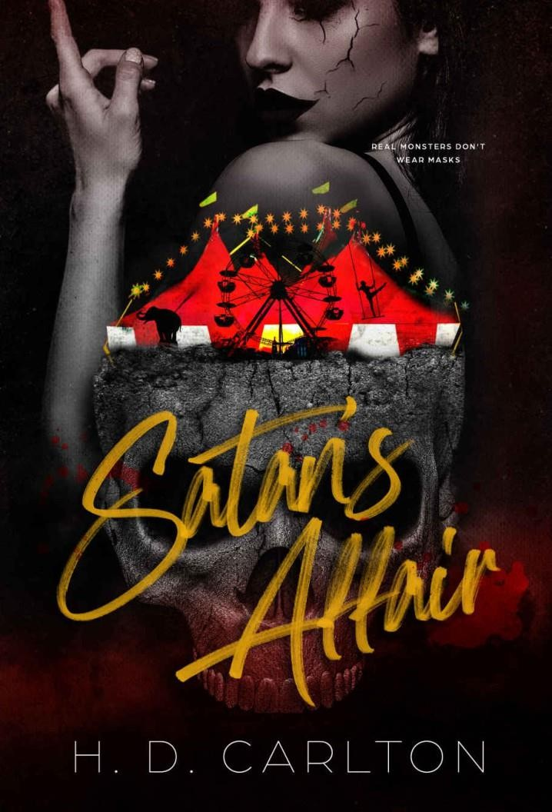

Satan’s Affair Copyright © 2021 by H. D. Carlton

All rights reserved. Printed in the United States of America. No part of this book may be used or reproduced in any manner
whatsoever without written permission except in the case of brief quotations em- bodied in critical articles or reviews.

This book is a work of fiction. Names, characters, businesses, organiza- tions, places, events and incidents either are the product of the author’s imagination or are used fictitiously. Any resemblance to actual persons, living or dead, events, or locales is entirely coincidental.

First Edition: April 2021
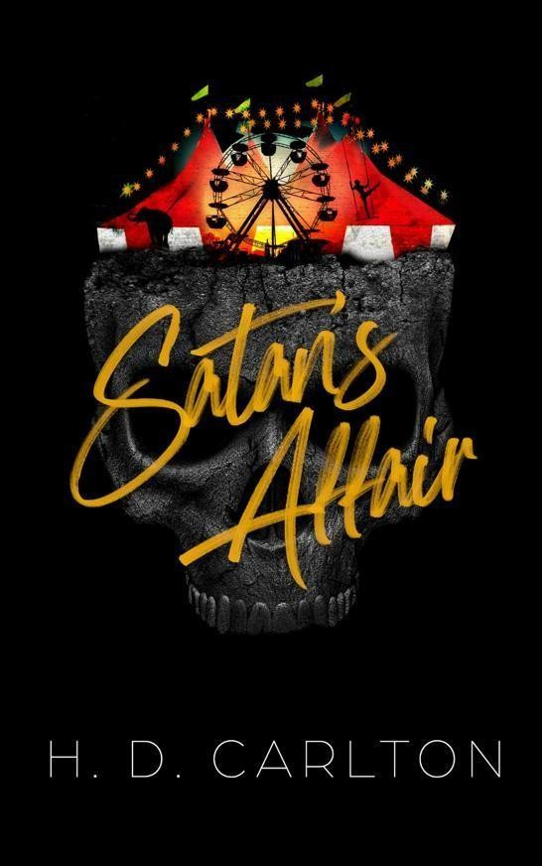

Contents

Chapter 1
Chapter 2
Chapter 3
Chapter 4
Chapter 5
Chapter 6
Chapter 7
Chapter 8
Chapter 9
Chapter 10
Chapter 11 Epilogue
For My Readers Acknowledgments About The Author
Playlist

Dollhouse- Melanie Martinez Carousel- Melanie Martinez Daisy- Ashnikko
STUPID- Ashnikko
Let the Bodies Hit the Floor- Drowning Pool Graveyard- Halsey
isaac’s insects- Isaac Dunbar mime- Isaac Dunbar


“One.” Stab. A grunt punctuates my next word, “Two.” Stab. Another grunt. “Freddy’s coming for you,” I sing, high-pitched and child-like. Blood spurts from his stab wounds, painting my face in a mosaic of red and gore.
The evil is seeping out of each hole I’ve made in his body. I can feel it, curling from the openings like smoke from the machines in nearly every corner of this house. I breathe in deep, smelling the evil coming out of him.
It smells like rotten egg and brimstone. It’s how I know that I made the right judgement.
“Mortis, come hold his head,” I order. My henchman listens immediately, gripping the man’s head in his red hands, rendering him still as his black talons dig into the demon’s face. His efforts to dislodge his head from Mortis’s grip are so cute.
Gripping my pretty knife in my hand, I lean down closely and start working the pointed tip around the edge of the man’s eyeball. It’s my favorite knife. The handle is bright pink and swirls at the end. I’ve had this knife since I was a little girl, it’s the only thing left I have of my mother’s.
The wriggling parasite’s screams intensify as my knife digs deeper, cutting around the inner edges of his eyelid as if I’m cutting a cake out
of a pan. Blood spurts from the orifice, nearly splattering into my own eyes.
I dig the knife down and then push up, popping the eyeball from its socket.
His eyes are such a pretty blue.
“Three, four, better lock your door,” I continue, my voice more subdued and distracted as pleasure sluices through every cell in my body and makes its way to the spot between my legs. Nothing gets me off more than my mission.
I throw the eyeball, the soft plop when it hits the wooden floor swallowed by the man’s screams.
Silly little thing. No one will ever hear you scream.
I shoo Mortis away, no longer needing him at the moment. Mortis steps away, reclaiming his position in the corner of the room.
The man beneath me wriggles, calling me all kinds of choice names. His words are garbled through the blood pouring in and out of his mouth. Must’ve hit a lung.
Whoopsie.
In my distraction, he manages to dislodge me from his body. I fly sideways, landing awkwardly on my side, the knife coming within inches of my face. He stumbles to his feet, while my henchman, Mortis, takes a step towards him.
“Let him go,” I order, watching my victim stagger to his feet and run out of the door. “I like the chase.”
I stand, and calmly walk out of the room. The house is completely barricaded. Unbeknownst to the owners of the fair, my henchmen and I painted the windows shut so demons couldn’t escape, while the emergency exit points are guarded by the rest of my henchmen.
There’s no chance of his escape. And I love to play games.
“Five, six, grab a crucifix,” I sing loudly, knowing he can hear me. I think I’m the one that needs the crucifix. The entire house is being filled with his rotten egg stench. I shudder, anxious to rid the house of it.
I look down either side of the hallway first. The smoke machines are off now, but the lack of ventilation in the house allows the colorful smoke to linger. They always dye the smoke all sorts of colors, creating a trippy effect when coupled with the strobe lights.
Now that the grounds outside of the house are empty, I turned all the flashing strobe lights back on and music filled with evil laughter, howling and zombie moans.
One of my henchmen, Jackal, stands at the very end of the hallway, the smoke concealing the majority of his body. What does poke through is his burnt face covered in boils, unnaturally wide smile stretching across his cheeks with blood dripping from his shark-like
teeth and big yellow eyes. His makeup was always more grotesque than the others, which is why I make him guard the doors. His burnt skin looks and feels real to the touch, but it’s all just makeup and prosthetics.
He doesn’t move, instead continuing to stare at me. He knows how much I enjoy the chase.
My eyes drop to the white hardwood floor, spotting a blood trail veering off to my left towards the staircase. He’s trying to leave me.
I follow the blood trail, a smile on my face. “Seven, eight, gonna stay up late.”
A thud from down the stairs resonates, right before a loud yelp. I giggle, already knowing he ran into one of my henchmen. Another loud bang and a frustrated scream. I hurry my steps, my heart pounding harder now that I know he’s being a bad boy.
When I reach the bottom of the Barbie pink steps, I swing around the banister and sing, “Nine, ten, never sleep again.”
“Fucking crazy ass bitch!” he screams from somewhere in the house.
I frown, hurt and angry by his words.
“I’m not crazy!” I screech. I take a deep, calming breath and arrange the smile back on my face. “I’m just passionate.”
To my left and through pink double doors is the living room. More colorful smoke fills the room, but the open concept of the bottom floor thins it out, making it easier to see. On the bright robin’s egg blue couch lays a mechanical pregnant woman giving birth to a demon. It feels like looking into the past, watching the birth of the current demon running rampant in my dollhouse.
The entire house is decorated in whites and pinks, with splashes of bright colors. The white stone fireplace in the corner of the living room is lined with dolls, all their faces melted or dirty, with patches of hair ripped from their skulls. The sight always makes me happy.
Excited once more, I head down the hallway leading back to the kitchen. His blood trail leads back there. Based off the handprint smudges and streaks of blood, he must’ve fell in there. Probably when he ran into Cronus.
After all, Cronus is the size of a Mac truck. He must be a body builder in his free time. His neck is the size of a tree trunk, his arms even bigger. Bulging veins cover the entirety of his body, especially his cock. It looks as if he has no mouth and eyes at all, convincing prosthetics covering them, so it looks as if his face is blank. I never bothered to ask how he sees—he’s a mute. I figured the eye prosthetics are see-through, as he never seems to have any problems seeing.
I walk through the kitchen and see the demon with an axe in his
hands, struggling to raise the heavy axe. He’s losing blood quickly, the adrenaline the only thing keeping his body functioning.
Pulsing rage has my eyes widening and lighting my insides on fire when he manages to swing the axe into the wall.
How dare he!
He can’t get through my henchmen, so he’s going to desecrate my pretty dollhouse and try to breakout through the walls.
“You’re really hurting my feelings, demon,” I say, announcing my arrival. He freezes at my voice. He’s as pale as a ghost, the color bleached from his skin. When he turns to see me and the angry scowl on my face, he turns and attempts to swing the axe more vigorously. Desperately. But he only manages to lodge the blade into the wall once more.
He’s too weak now.
“Cronus!” I screech, stomping my foot. “He’s making my dollhouse ugly!”
Cronus comes walking in the room, but the demon doesn’t acknowledge him. He’s too focused on his escape.
I point my finger. “Get him to stop,” I whine.
Cronus walks over to the man. Feeling my henchman coming for him, the guy swings his axe around wildly, a crazed gleam in his one eye. He releases a battle cry, but Cronus easily swipes the sharp weapon from the man’s grip. He grabs either end of the axe and cracks it over his knee, snapping it in two like a twig.
The man’s eye widens. It used to be a pretty blue, but his pupil has completely taken over, morphing it into a nearly black eye—just like a true demon. His eye darts around the room, sliding past me as if I’m not there to find an escape route, but there is none.
You can’t hide from fate. That’s the funny thing about destiny, even if you try to escape it, it will always find you.
Cronus’s arm snaps out faster than a whip and grabs the man by his throat. He brings him close to his face. The man thrashes in his hold, and screams in his face, a mix of fear and frustration. I join Cronus’s side, but he doesn’t even pay me attention. Not when there’s a behemoth of a man holding you into his missing face.
“Bring him back to my room,” I order, turning around without another glance. Cronus drags him behind me, ignoring the punches and kicks to his limbs. I enter my cute, pink bedroom, Mortis still waiting in the corner of the room. He leans against the wall, arms crossed over his chest with a bored look on his face. He almost looks frozen.
I don’t pay him any mind yet, my attention too focused on the demon being carted in the room behind me. Adrenaline surges, and my hands nearly tremble with the desire beginning to course through
READ MORE

